

APPLICATION / PROGRAM REQUEST FORM
AI Dashboard & Automation Platform
Thank you for your participation in developing our AI Dashboard and Automation Platform. This form is designed to help the IT Team better understand your needs and implement the right solutions.
Please complete this form in as much detail as possible. The information you provide will greatly help us in designing and implementing solutions that meet your team's needs.

1. REQUESTOR INFORMATION
Requestor Name | Ari Eko Susilo
Team / Department | HRGA
Position / Title | HRGA Supervisor
Email | ari@ckd-otto.com
Phone / Extension | 204
Submission Date | 26-02-2026

2. REQUEST INFORMATION
Request Title | Budget Monitoring
Request Type | ☐ New Application  ☐ Automation Program/Script  ☐ Dashboard/Report  ☐ System Integration  ☐ AI Feature/Automation  ☐ Other: _________________
Priority | ☐ Urgent (< 1 month)  ☐ High (1-3 months)  ☐ Medium (3-6 months)  ☐ Low (> 6 months)

3. BACKGROUND AND OBJECTIVES

3.1 Problem Description / Business Need
Describe the problem or need driving this request. What is currently not working optimally or what do you want to achieve?
During the annual budget preparation, we face challenges in manually gathering data one by one, which is extremely time-consuming.

Mitigating Overspending and Underspending Risks
Without strict monitoring, organizations often encounter two major problems:

Overspending: Expenditures exceed the set ceiling, which can disrupt cash flow.
Underspending: The budget is not optimally absorbed, which could mean that strategic programs are not running optimally.
This dashboard provides an early warning system through trend visualization to keep budgets on track.

3.2 Objectives and Benefits
What objectives do you want to achieve with this application/program? What benefits are expected for the Team?
By monitoring the HRGA budget, we can access detailed expenditure history, track reclassifications, and identify available open budget (for urgent needs). This will also result in a faster and more efficient annual budgeting process for the following year.

Expense Prediction: Companies know exactly when large obligations must be paid, so cash reserves can be managed more effectively.

Priority Scale: If cash flow is tight, management can delay non-priority expenses based on dashboard data.

Culture of Savings: The awareness that every expense is monitored will encourage teams to find more efficient ways of working.

Objectivity: Manager performance evaluations can be based on their ability to manage business units according to agreed budgets.

Realistic Budgets: You no longer have to guess at numbers, but can use actual trends as a reference.

Investment Justification: It is easier for management to approve new budgets if data shows that previous expenditures provided a positive ROI (Return on Investment).

3.3 Current Process (As-Is State)
How is the process currently running? Describe the workflow, tools, or methods being used.
- Accessing Oracle expense data.
- Manually inputting data from Oracle into Excel, one by one.

4. DETAILED SPECIFICATIONS

4.1 Main Functions / Features
List the main functions or features needed. Provide details for each feature.
- Feature 1: Monitoring budget all account/month
Each HRGA account automatically appears on the dashboard based on its usage.
Can view the history of reclassifications between accounts and open budgets.
Can find out details of budget usage, for example stationery account in March:
- Paper 2,000,000
- Glue 500,000
- Ballpoint pens 200,000
- etc.
- Feature 2: Options for 'Year' and 'Month' are available for each period.
- Feature 3: Capable of predicting budget requirements for each account in the following year.
- Feature 4: Visual charts are available.

4.2 Input Data
What data will be the input? What are the data sources? Data format (Excel, CSV, Database, Manual Input, etc.)?
Automatically from Oracle to Budget Monitoring Dashboard

4.3 Expected Output / Results
What output is expected? (Report, Dashboard, File Export, Notification, Automated Action, etc.). Describe the format and content of the output.
MEETING

Period
Import from Oracle
Export

January
2026

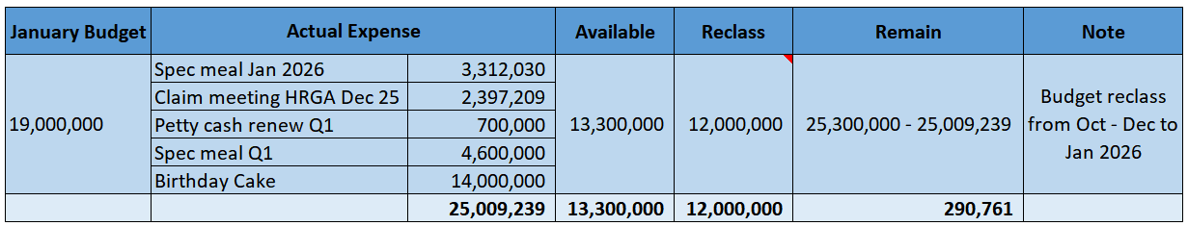

4.4 Desired Process / Workflow
Describe step-by-step how the application/program should work. Illustrate the process flow from input to output.
- Login the dashboard
- Go to “HRGA Budget Monitoring” menu
- Set Date Range (period)
- Click “Import” to start process importing from oracle to the dashboard
- Click “export” to download

4.5 Parameters / Configuration
Are there any specific parameters, filters, or configurations needed? (e.g., time period, product category etc.)
Monthly

5. SYSTEM INTEGRATION

5.1 Related Systems / Applications
Does this application/program need to integrate with existing systems? Specify system names and types of integration.
- Historical data from oracle to HRGA dashboard

5.2 Data to be Shared Between Systems
What data needs to be shared or synchronized with other systems?
Between oracle & budget monitoring dashboard

6. USER AND ACCESS MANAGEMENT
Number of Users | 3
User Roles / Levels | Manager, Supervisor, Officer
Access Rights | Read, update

7. AI & AUTOMATION FEATURES (If Applicable)

7.1 Desired Automation
What processes do you want to automate? Automation frequency (real-time, daily, weekly, monthly)?
Monthly

7.2 Required AI Features
Do you need AI for: prediction, classification, recommendation, analysis or others?
- AI can provide analysis of ongoing budget usage.

7.3 Automation Triggers / Conditions
What triggers the automation? (event-based, time-based, condition-based, etc.)
Time-based, at the end of every month

8. SECURITY & COMPLIANCE

8.1 Data Sensitivity
Will this application handle sensitive or confidential data? If yes, specify the types of data.
☐ Personal Data (PII)
☐ Financial Data
☐ Product Formula Data

☐ Company Confidential Data
☐ Other: _________________

9. ADDITIONAL INFORMATION

9.1 References / Examples
Are there any reference applications that can be used as examples? (screenshots, links, or descriptions)
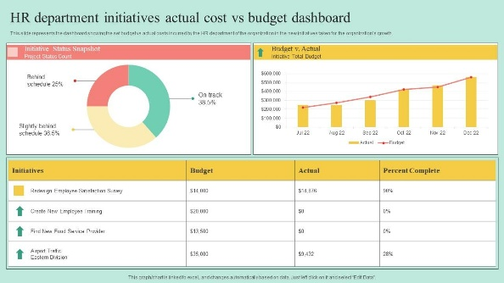

9.2 Attachments
Attach supporting files if available (sample data, mockups, flow diagrams, screenshots, etc.)
Attached files:
- Budget monitoring (manual) HRGA template

APPROVAL
Submitted By | Approved By (Team Head)
Name: Ari Eko Susilo  Date: March 5th, 2026 | Name: Ellvin  Date: March 5th, 2026

After completing this form, please send it to the IT Team via email or ticketing system.
The IT Team will review and contact you for further discussion.

